Vector Processing:
Vector processing is the processing of large data of large one-dimentional arrays called vectors using special processor and instruction set which can handle processing such data simultaneouly instead of one per cycle.the most common example of vector processing is training a mathematical model for prediction porposes.It mainly impliments single instruction, multiple data (SIMD) processing of data. The architecture of a vector processor is as follows:
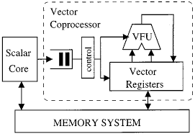

The applications of vector processing are:
- Image Processing
- Artificial Intelligence
- Human Genome Mapping
- Simulations
- Weather Predictions

Array Processing:
Array processing is a wide area of research in the field of data processing that extends from the simplest form of 1 dimensional line arrays to 2 and 3 dimensional array geometries. The most common example of array processing is graphics processing that occurs in a graphics card of a computer.A GPU processes the 2D array of values of a picture called a raster and displays it on the screen.The architecture of a array processor is as follows:

